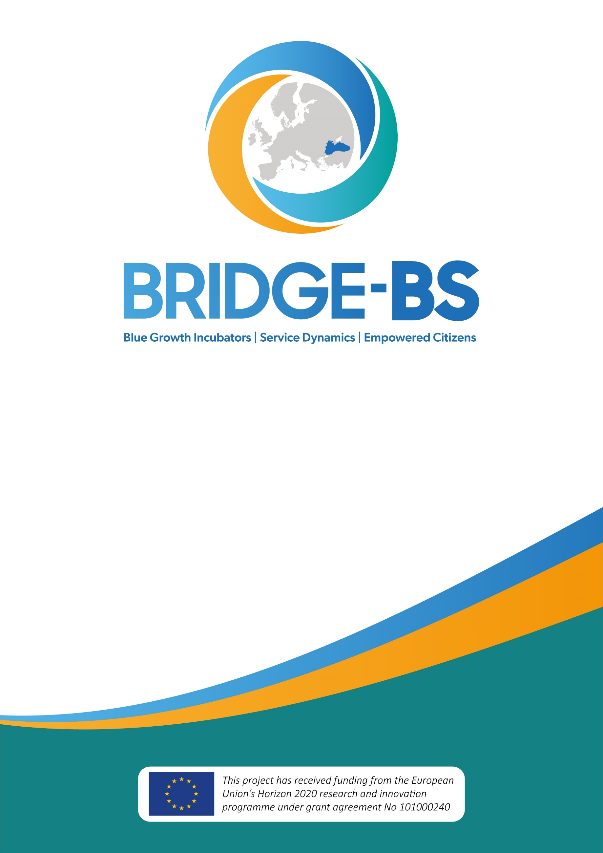
BRIDGE-BS SUMMER SCHOOL
23-25 August 2022
Istanbul University in Istanbul, Turkey

Draft Concept Note
The preservation of the Black Sea is vital to the prosperity of its coastal communities due to the unique habitats, abundant resources, and rich cultural heritage it offers. Furthermore, ecosystem preservation - through green innovation and circular models - is becoming imperative to foster sustainable economic development and new business models for the industry and other socio-economic actors in the sea basin.
The Black Sea is a distinctive semi-enclosed basin with 10 large rivers flowing into a highly coupled coastal-deep-sea system introducing anthropogenically generated nutrients and pollutants nourishing the largest anoxic-sulfidic water body on the Earth. The Black Sea ecosystem is worryingly damaged by persisting negative consequences due to human-induced activities (stressors) and challenges due to climate change. Such negative patterns are increasingly threatening the Black Sea fragile ecosystem and, as a consequence, are posing serious challenges to socio-economic future activities in the region. Amongst such stressors are eutrophication and hypoxia, overfishing, litter and pollution by industrial and human activities, and the introduction of alien species.
Understanding and addressing such multi-stressors, including through the promotion of transformative innovation across the various Blue Economy activities in the region, is, therefore, a central challenge to be tackled by BRIDGE-BS.In this respect, the EC H2020 BRIDGE-BS R&I project aims to develop the predictive tools and capabilities necessary to understand and address the impacts of climate-driven and anthropogenic multi-stressors on the services stemming from Black Sea ecosystems. These services and their responses to stressors will be mapped, monitored, and modeled to identify a safe operating space within which a sustainable blue economy can flourish. Transformative sustainable technologies will also be discussed and fostered in their uptake across operators and socio-economic actors.
Moreover, a range of educational and capacity-building activities are supported by BRIDGE-BS. Amongst those, a summer school will be organized by the BRIDGE-BS project by targeting graduate students from Black Sea riparian countries in the last week of August 2022 (for a total of 4 days, including the arrival day) and will be hosted by one of the facilities of the Istanbul University (IU).
The courses provided during the summer school will cover the main aspects related to the Black Sea ecosystem and the challenges and opportunities faced by prominent economic activities for a sustainable Blue Economy in the Black Sea: i) management of marine living resources (fisheries and aquaculture), ii) green ports and sustainable transport, iii) coastal and maritime tourism, iv) renewable marine energies, v) blue-biotechs. A scientific coordinator from the host country (IU, Turkey) will guide the school’s activities and syllabus preparation.
Full accommodation, travel, and catering expenses of the summer school participants will be covered by Istanbul University
Objectives
- Equip graduate students with theoretical and practical skills to address issues faced by a sustainable Blue Economy in the Black Sea with a specific focus on regional policy initiatives - including the Common Maritime Agenda (CMA) for the Black Sea, and the Strategic Research and Innovation Agenda (SRIA.) - as well as key regional actors - such as the Black Sea Commission (BSC) and the Organisation for Black Sea Economic Cooperation (BSEC).
- Diversify possible career pathways for the next generations of practitioners in the sectors, towards new emerging sectors, skill-sets, and competencies that are required to foster a transformational Blue Economy in the region.
- Widen the next generation’s comprehension and appreciation of fundamental marine ecosystem functioning, challenges, and opportunities for its preservation, to train future leaders for a sustainable Blue Economy.
- Learn about opportunities in sustainable innovation and policy support across relevant marine and maritime sectors in the Black Sea as well as other EU sea basins, and understand the policy context in which to grow as a professional.
- Foster professional and educational networks and international partnerships that can improve activities in support of sustainable blue growth, and become part of the broader community of innovation professionals across the region.
- Stimulate actions for preservation and sustainable exploitation of the Black Sea marine and coastal ecosystems, and make students understand how green innovation can help a successful and fulfilling career pathway in the region.
- Improve the matchmaking of regional businesses/organizations and young professionals equipped with innovative skill-sets for innovating the Blue Economy and ocean governance, towards achieving the UNSustainable Development Goals in the Black Sea.
Date and Venue
23-24-25 August 2022 at Istanbul University in Istanbul, Turkey
Application
- Fill out an online application form
- Submit an up-to-date CV or resume that shows your educational background and work experience
- Provide a statement of support from the student’s institution/university
- Deadline: 30 June 2022
Fees, Costs, and Visa
- All selected participants will attend the summer school free of charge and in person.
- Selected participants’ accommodation (4 nights in shared dormitories: 2-people of the same gender), lunches, and some dinners will be covered by Istanbul University.
- Subsistence costs in Istanbul for the duration of the training, are borne by the participants.
- All participants are responsible for complying with the entry requirements to Turkey. Participants who need to be in possession of a visa should organize their visa procedure and cover the costs of granting it. Istanbul University and BRIDGE-BS Project support the accepted candidates with an invitation letter.
- Accommodation and travel arrangements will be organized by Istanbul University for the selected students.
Selected applicants will receive confirmation and further practical details. Please do not make any travel arrangements before you receive the confirmation email.
Requirements
Candidates should fulfill the following conditions:
● Only graduate students of any discipline related to the Blue Economy (economy, research, and/or policy) will be considered;
● Candidates should be graduate students from Bulgaria, Georgia, Romania, Moldova, Turkey, and Ukraine;
● Candidates should have a good working knowledge of English (level B2 or higher);
Please note that: we offer introductory lessons on the main concepts and practices related to the sustainable blue economy and the themes relevant to the Black Sea region. This year, the summer school will focus on the following blue economy topics (see table below).

Draft Agenda

22.08.2022 - Arrival
23.08.2022 (1. Day)
09:00 - 09:30 | Opening Remarks  Tour de Table, Ice-breaker
09:30 – 10:00 | Welcome Speech and Introduction of BRIDGE-BS Project  Prof. Cem Gazioğlu, Istanbul University  Prof. Baris Salihoglu and Assoc. Prof. Mustafa Yucel METU-IMS & Coordinators of the BRIDGE-BS Project
10:00 – 10:45 | Introduction to Oceanography  Prof. Dr. Baris Salihoglu from METU-IMS, Turkey
10:45 – 11:00 | Coffee Break
11:00 - 11:45 | Resilience of Ecosystems  Dr. Susa Niiranen from Stockholm University, Sweden
11:45 - 12:30 | Policy Framework  Frederick Herpers, SML & Matteo Bocci, SML
12:30 - 13:30 | Lunch
13:30 - 17:00 | Marine Living Resources: Fisheries and Aquaculture  Overview of trends, challenges, and opportunities (30 min)  Exchange with the students and Q&A (30 min)  Case study with International Practitioners (45 min)  Gizem Akkus, Black Sea Young Ambassador and Ph.D. student at METU IMS  Experts from the Turkish Marine Research Foundation  Exercise/Group work (45 min) and presentation of the group work (30 min)  Wrap-up and summary
18:00 | Dinner
24.08.2022 (2. Day)
09:00 - 09:30 | Deep Ecosystem of the Black Sea and Sustainable Blue Economy  Assoc. Prof. Mustafa Yucel, METU IMS
09:30 - 12:30 | Black Sea Renewable Energy  Overview of trends, challenges, and opportunities (30 min)  Exchange with the students and Q&A (30 min)  Case study with International Practitioners (45 min)  Arthur SERMENT, PMM  Mauro Randone, WWF (TBC)  DURED (TBC)  Exercise/Group work (45 min) and presentation of the group work (30 min)
12:30 - 13:30 | Lunch
13:30 - 17:00 | Blue Biotechnology  Overview of trends, challenges, and opportunities (30 min)  Exchange with the students and Q&A (30 min)  Case study with International Practitioners (45 min)  Dr. George Triantaphyllidis, HCMR (TBC)  Prof. Murat Telli, Beta ALG Biotechnology  Exercise/Group work (45 min) and presentation of the group work (30 min)  Wrap-up and summary
18:00 | City Tour and Dinner TBC
25.08.2022 (3. Day)
09:00 - 09:15 | Opening Remarks and Summary of Day 2
09:15 - 09:30 | Introduction of the Virtual Blue Career Center  Dr. Petar Georgiev, Marine Cluster Bulgaria (TBC)
09:30 - 12:30 | Coastal and Maritime Tourism  Overview of trends, challenges, and opportunities (30 min)  Exchange with the students and Q&A (30 min)  Case study with International Practitioners (45 min)  Digitalization in tourism: Mamuka Berdzenishvili  Ecotourim: (Mare Nostrum (TBC)  Chantel Beuvink – Natural Greece (TBC)  Future in Tourism Project (TBC)  Exercise/Group work (45 min) and presentation of the group work (30 min)
12:30 - 13:30 | Lunch
13:30 - 16:00 | Maritime Transport  Overview of trends, challenges, and opportunities (30 min)  Exchange with the students and Q&A (30 min)  Case study with International Practitioners (45 min)  Marine Cluster Bulgaria (TBC)  Raúl Cascajo Jiménez, MedPort Association  Anna Natova, Bulgarian Port Infrastructure Company (TBC)  WestMED Ports as Energy Communities (Technical Group)  Sebastian Blicher, Black Sea Young Ambassador (Deck Officer)  Exercise/Group work (45 min) and presentation of the group work (30 min)  Wrap-up and summary
16:00 | Closing Remarks and Farewell Activity

Main Lecturers:

On the first day, a general introduction will be made by various experts. The Summer School will be facilitated by Frederick Herpers and Matteo Bocci. Under each sector, specific case studies will also be presented with relevant International Practitioners.
Frederick Herpers: Frédérick is an engineer in hydrography and oceanography with 13 years of experience in geophysics for civilian and military purposes (e.g., at France’s hydrographic office (SHOM) and the Ministry of Defence’s procurement agency). He is experienced in the design and implementation of integrated maritime and coastal policies at the EU, national, regional, and local levels. In a previous position as an Integrated Maritime Policy (IMP) advisor for the French Prime Minister at the General Secretariat for the Sea (SG Mer), he contributed to the development of French maritime policy, notably serving as project manager on maritime issues for France’s ‘Grenelle de la Mer’ in 2009 where he was primarily tasked with inter-ministerial coordination.
As a consultant since 2014 at Stratégies Mer et Littoral (SML), he has been involved in several projects related to Blue Economy in the Atlantic, the Mediterranean, and the Black Sea mobilizing his skills and experience in legal and technical matters to develop and implement endorsed maritime strategies and to engage stakeholders in a sustainable blue economy. He has been the national hub for France since 2018 for WestMed and since 2020 for the Atlantic Action Plan. Since 2018, he has been working in the Black Sea with the Black Sea Blue Growth facility which contributed to setting the Common Maritime Agenda, and the team leader of the Black Sea assistance Mechanism (BSAM).
Matteo Bocci: Matteo holds a Master’s degree in Public Affairs and Administration (MPA) from the London School of Economics (LSE) and Sciences Po Paris and has over 20 years of professional experience. Matteo has worked on Blue Economy topics since the development of the Blue Growth Study for the European Commission’s DG MARE in 2012 and has worked on many research and capacity-building assignments in Blue Economy, across various EU sea basins including the Black Sea. His principal areas of expertise include blue innovation, research, cluster analysis, tourism, and renewable energy, as well as governance and support for Integrated Maritime Policy (IMP). He has served as Deputy Leader for the West Med Initiative promoted by the EU Commission (DG GROW/NEAR) and as Blue Economy Expert for a DG NEAR project on Blue Economy in ENI South Countries. He has also been a member of several core teams responsible for strategic studies, evaluations, and impact assessments for the EU Institutions (Commission, Parliament) in a variety of policy fields. Matteo was involved in the previous contract for the definition of the Common Maritime Agenda.

